**COMPILER ASSSIGNMENT**

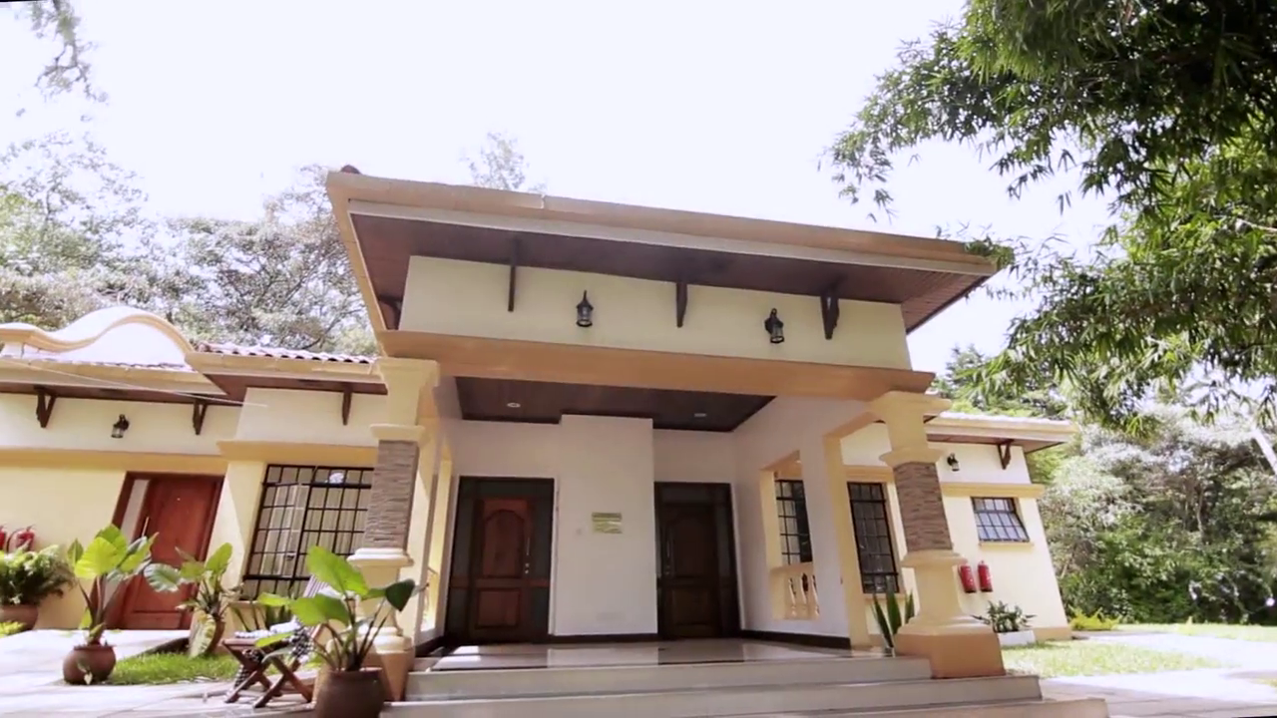

**NAME:** SAMUEL NJENGA

**COURSE NAME:** BTECH: INFO TECH

**REG NO:** SCII/03458P/2016

Distinction between top down parsing and bottom up parsing

TYPES OF PARSING

Parsing or synatantic analysis is the process of analyzing a string of symbols according to the rules of formal grammar.

It’s a technique that takes input string and produces output either a parse tree if string is valid sentence of grammar or an error message indicating that string is not a valid sentence of a given grammar.

Types of parsing are top down parsing and bottom up parsing

In top down parser

* Parsing start at the root of the parse tree and grow towards leaves.
* Pick a production and try to match the input
* Bad pick may need to backtrack
* Some grammars are backtrackfree

In bottom up parser

* Start at the leaves and grow towards root
* As input is consumed ,encode possibilities in an intenal state
* Start in a state valid for legal first tokens
* Handles a large class of grammar

Question2

1. What is the difference between parse tree and syntax tree? Write appropriate grammar and draw parse as well as syntax tree for a*(a-a^a)

Trees are ordered, rooted that represents the syntactic structure of a string according according to some context free grammar,in compilation this are the parse tree and syntax tree.

In parse tree nodes are non teminals,leaves are terminals whereas in syntax tree internal nodes are operators,leaves are operands.

Parse tree are rarely constructed as a data structure unlike syntax a program is represented as a tree structure

Parse tree represents the concrete syntax of a program while syntax tree represents the abstract syntax of a program

Parse tree for a*(a-a^a)

a1🡪a^a

a2🡪a-a1

a3🡪a*a2

a3

a * a2

a - a1

a ^ a

syntax tree

*

a -

a ^

a a

references

(Loftsson, 2008)Loftsson, H. (2008). Parsing techniques, (October), 1–18.

https://doi.org/10.1007/978-0-387-68954-8

Nijholt, A. (1983). Deterministic Top-Down and Bottom-Up Parsing: Historical Notes and Bibliographies, (September 2016), 4–6.

(Nijholt, 1983)Loftsson, H. (2008). Parsing techniques, (October), 1–18. https://doi.org/10.1007/978-0-387-68954-8

Nijholt, A. (1983). Deterministic Top-Down and Bottom-Up Parsing: Historical Notes and Bibliographies, (September 2016), 4–6.